Minutes of the Combined Probus Club of Belrose General Meeting held on 14th April 2022 at the Uniting Church, Morgan Road, Belrose.

Meeting was opened at 10.05am by Vice President Ros Thompson.

Attendance:
Members attending 83
Apologies 20
Absent: 17
Visitors: 5

Vice President welcomed members and guests to the meeting and read a message of thanks and support from President Elizabeth Pawsey on her recent operation.

Birthdays for the month
Terry Stewart, Helen Morse, David Walker, John Duce, Susan Allsop, Margaret Krajancic, Neville Marsh, Rob Murphy, Hastings Pawsey, Bill Hardman, Robyn Wood, Betty Crawford.

Previous General Meeting’s Minutes
Moved by Lesley Walker (Secretary) that the minutes for the March General Meeting as posted on the club’s website are a true and correct record.
Seconded by Robyn Wood.
Carried.

Correspondence
Inward: Renewal of annual subscriptions from many members.
Documentation from Probus South Pacific re capitation fees and names of new committee for 2022.
Outward: Broadcast re Pearl Farm Outing.
Broadcast re Bare Island Trip.

Treasurers Report
Presented by Colin Fordred

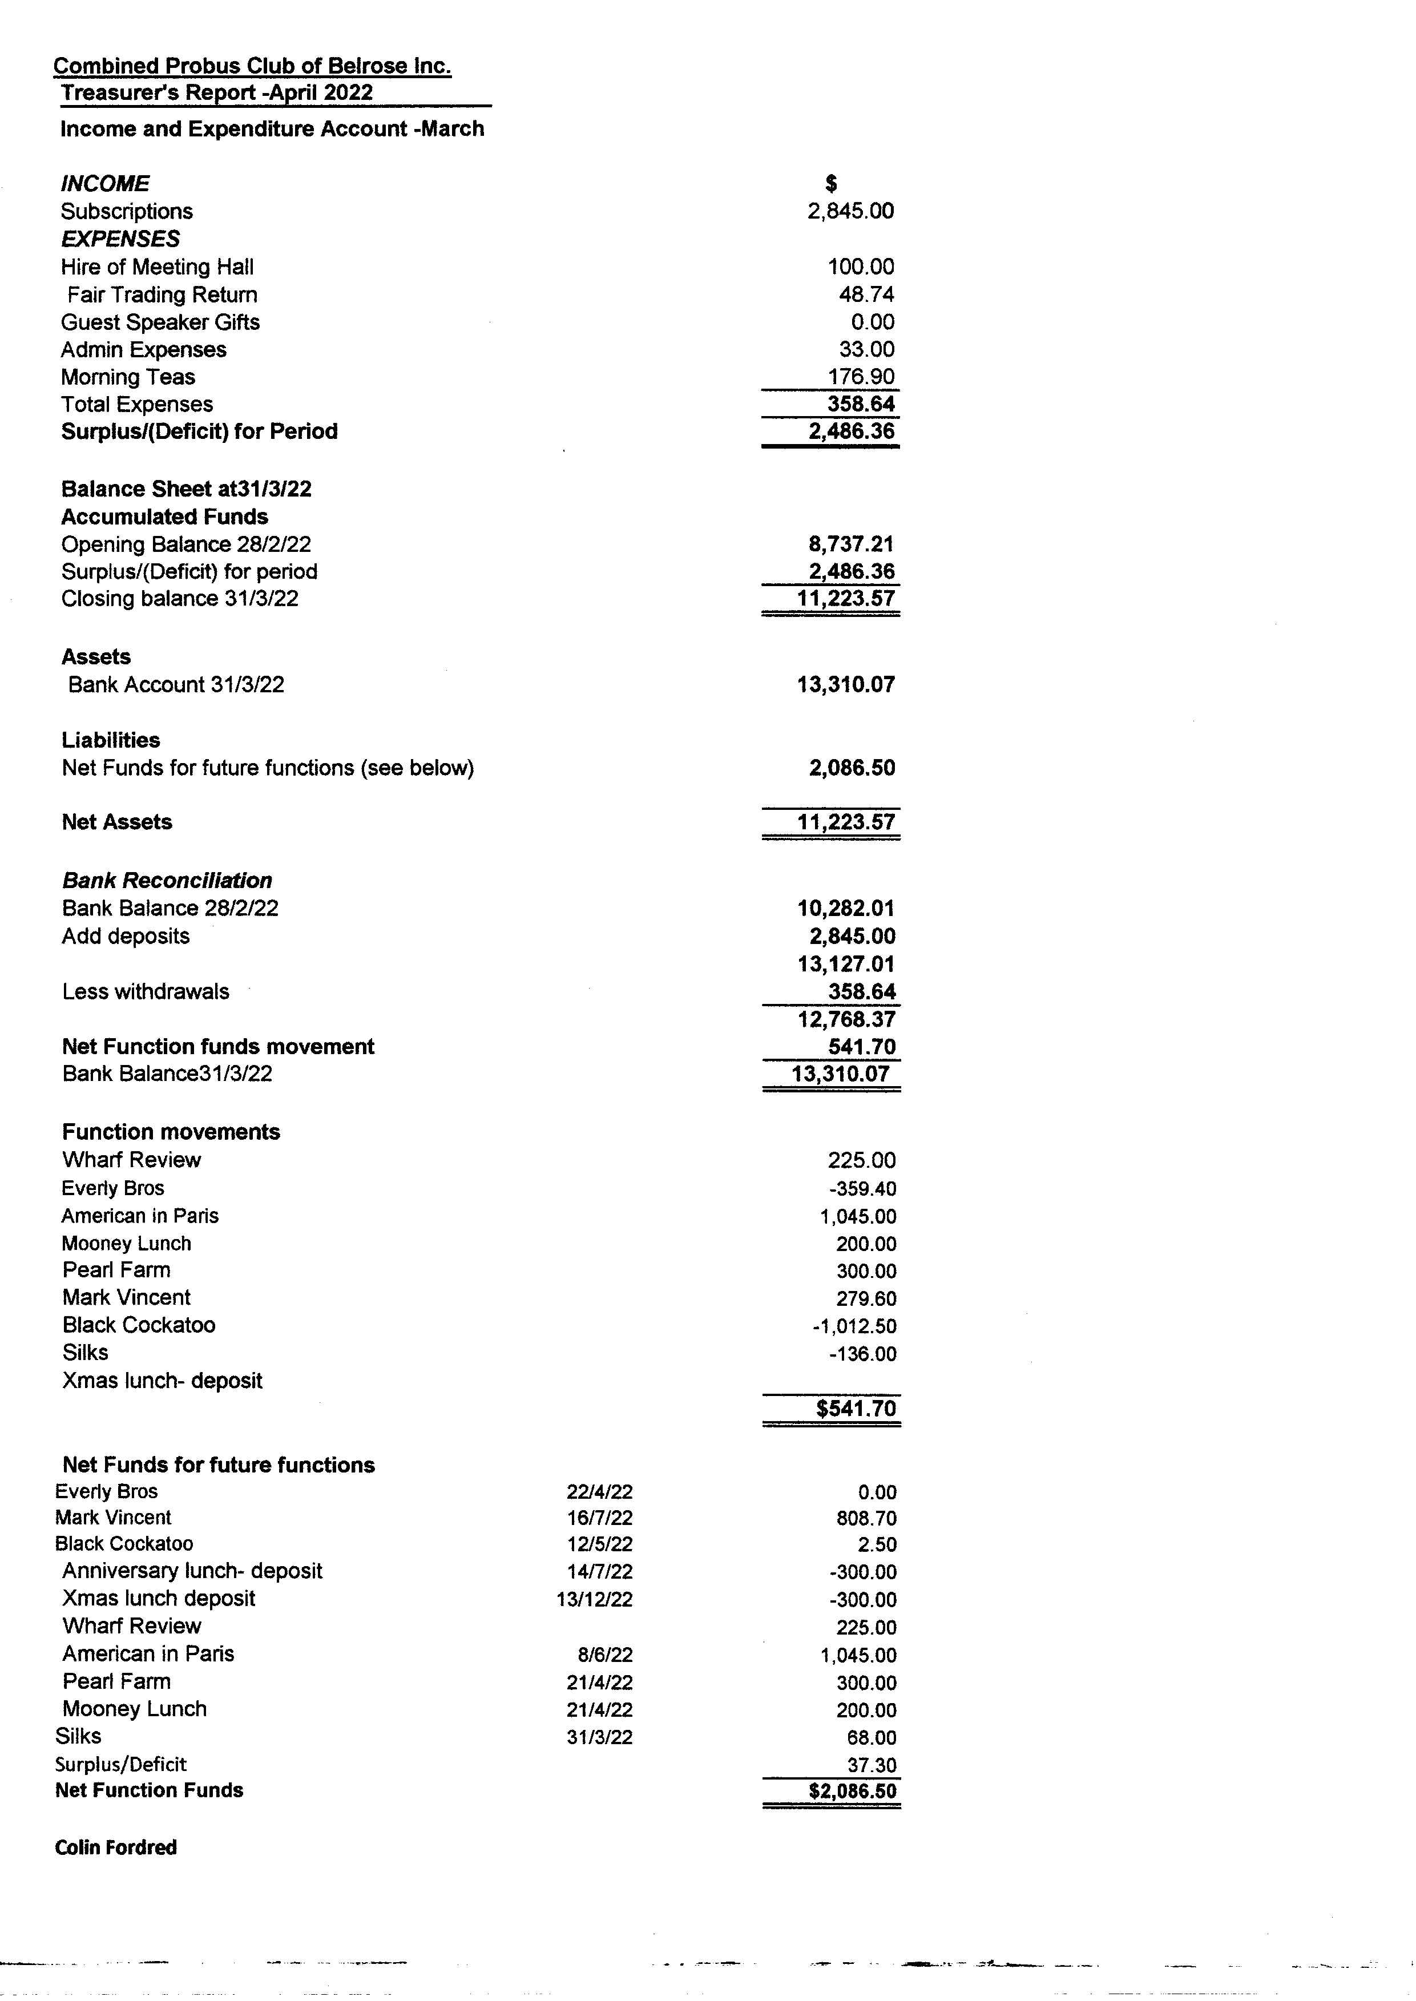

Social Report
Report presented by Tony Lovett in Margaret’s absence.

Silk Restaurant dinner a successful with 38 members attending.
Mooney Mooney lunch outing 21 April. Numbers very low so a block booking was cancelled and left to those members still going to pay as they go.

May 19th – Lunch at Frankies at Flower Power Terrey Hills.
Members to let Margaret know re attendance. Meal is a pay as you go system. Numbers needed by 10th May.

July 28th: Anniversary dinner at Royal Motor Yacht Club Newport.
Menu and price yet to be advised.

Dec 13th: (Tuesday) Christmas Lunch at Terrey Hills Golf Club.

Outings Report
Presented by Margaret Ayre.

Dine and Discover vouchers can be used for the Pearl Farm and Zoo outings.

Pearl Farm: Numbers are very low. This trip may have to be cancelled.

Bare Island Tour: Monday 16th May. Cost $82 per person which includes morning tea, lunch, a guided tour of 1.5 hours of Bare Island and coach. Leaving at 8.30am.
Numbers required asap for this trip but so far, a good response.

Sydney Zoo: 2nd June. Cost will be determined on numbers but could be $30 per person for coach.
With Dine and Discover voucher cost is $29.99 online which members must redeem themselves or $36 dollars pp to pay at the gate. Numbers required asap.

Yulefest: 8 August.

This is a trip to the Carrington Hotel Katoomba.
Have booked 20 rooms all ensuite. Book in at 2pm. This is a Christmas in August function which will include 4 course dinner, bed and continental breakfast. Cost is Single $257.00 Twin $319.00 per room. Numbers required by end of June. Members to make their own way by own vehicle or use public transport.

Entertainment Report
Presented by Warwick Brady

In March at Glen Street, we saw a fantastic Show Music of the Night this was a BRILLIANT SHOW and a really wonderful experience for our 60 members who had tickets. We spoke to the cast after the show and assured them that if they were back at Glen Street in 2023 there would be large numbers from our Club.
How unfortunate we were when two of the cast of Wharf Revue suffered from Covid which led to the first one and a half week of the show being cancelled, and this included our booking. Hopefully maybe the show will return later in the year. At present all payments made have been refunded. Thanks Colin.

April commenced with a Monday morning show of My Fair Laddies. Twenty-Five Club members enjoyed Glenn Amer one of Glen Street Theatre favourite performers.

We are all looking forward to the Everly Brothers and the Rock & Roll Legends of the 50's and 60's on the 22nd April at 8.00pm. This show was always popular for Club Members 45 members had reserved seats but numbers increased by 12 to 57 after we learnt the Williams Bros supported by the Shy Guys a fabulous award winning live band who had entertained us earlier in the year at the Australian & American Bandstand show and gave us a performance to remember were the stars of this show .

May starts with 9 - 5 the Dolly Parton show. We have 36 members who are anxious to see this show. on the 4th May at the Capitol Theatre.

Back to Glen Street on the 12th May for Black Cockatoo at 8.00pm. We are looking forward to seeing this show which is a story not just about cricket but is a story of strength, resistance, hope and possibility. We have 22 members attending.

All tickets for any of the above shows have been paid.

On the 8th June we are attending the new Theatre Royal in the city to see An American in Paris. Thanks for the terrific support I have had to increase our numbers three times. We are now up to 39. Payments of $95.00 per ticket and all payments are required 14th April at the latest . Great support for a show which is currently running to full houses in Melbourne.

Following my advice that we were the first Club to make a booking for the Mark Vincent Show - The Impossible Dream on 16th July at 8.00 at Glen Street Theatre. I have 47 reservations at the moment, and I have another 9 tickets on hold. Please confirm your reservations today. Tickets $69.90 each.

Finally, today I have made a booking for the Sapphires a multi award winning musical play which is full of raw energy, comedy, romance, and unbeatable soul music. Our show is booked for Friday 12th August at 7.30pm. Tickets are $67.50. I have reserved 20 tickets, but more are available if I get an indication from members today if you are interested. Payment is not due until 1st July.

Wow what a year we are having, let’s hope all shows go ahead without any further cancellations.

Membership Report
Presented by Tony Lovett

Membership Report – April 2022 – Members’ Meeting

Current Membership
Membership stands at 121 financial members (69 ladies, 52 Gents) (57%:43%)

Non-Active Members 3 (3 Ladies, 0 Gents)

Waiting List: 16 (12 ladies, 4 Gents)

Members in Attendance March 2022
Attendance at meeting
Members – 76
Visitors – 0
Total 76 attending Meeting

Apologies – 20
Absent - 25

Leave of Absence – 0

Information for April 2022 Meeting

Visitors Attending Meeting
Guest Speaker – Diana Noyce
Debbie Buckingham
Janet Macaskill
Dianne Pill
Ian Rickard
Marjorie Rickard

Note – Currently we have one additional visitor from the Waiting List who will be attending in May.

Narelle Colman has returned to Probus as a full-time member. Narelle was previously a non-Active member

As at the time of this report there are 20 people still to pay their membership renewals

All payments are due as at the time of the April general meeting.

Guest Speaker Report
Presented by Mike Staniland for Jan Staniland

Guest Speaker today will be Diana Noyce – Food Historian. Diana will speak to us about how other countries celebrate Easter with food.

Guest Speaker for May will be Kez Hesanic from the Maritime Museum who will talk about the sinking of the Lusitania by a German submarine in WW1 – a real detective story that throws light on the truth and reasons why the ship sank in only 18 minutes with over 1200 men, women and children on board.

Welfare Report

Robyn Wood reported on Elizabeth Pawsey’s progress after her operation and welcomed back Lesley Walker and Rob Murphy after their recovery from surgery.

Walking Group Report
Presented by Helen Miles

Many walks have been cancelled due to weather.
The April walk will be held on Friday 29th April and Lead by Ted Morton.
The walk will proceed clockwise along Ocean St, across to the lake and around the foreshore. After coffee we will continue to the shops then cross the bridge and continue between the lagoon inlet and caravan park around to the ocean side bridge.

Special General Business
Officers and committee members shall be elected annually. Members may serve for not more than three successive years in any one office except as otherwise determined and recommended by the committee. Prior to the AGM the committee received offers from Tony Lovett (Membership) and Warwick Brady (Entertainment) to fill the vacancies.

Following the committee meeting held on Thursday 28th March it was recommend that the membership ratify the committee’s decision to accept the offers from Tony and Warwick.

Moved by Ros Thompson seconded by Hastings Pawsey.
That the Club membership ratify the appointments of Tony Lovett (Membership) and Warwick Brady (Entertainment) for another 12-month period, to fill the vacancies on the committee.
Carried.

General Business
The Membership was informed of a Fashion Parade to be held by the Forest Kirk Women’s Evening Fellowship on Saturday 14th May at the Forest Kirk Uniting Church at 2.00pm.

Morning Tea Break
Today we were treated to some simnel cake made by Jane White.

Before the speaker commenced Vic President Ros informed the visitors who are awaiting membership to the club are very welcome to join in any club functions such as lunches/dinners and outings.

Guest Speaker was Diana Noyce who spoke on Easter foods in different countries. She was introduced by Ros Thompson and thanked by Mike Staniland.

The meeting finished at 11.45am.

The next General Meeting will be held on Thursday 12th May at 10.00am

Signed………………………………………………………………. Date……………………………………

25/04/2022

